Sample PUT Request:

Type : JSON

Description : Update an employee record

Checking Details of an employee before running the PUT Request

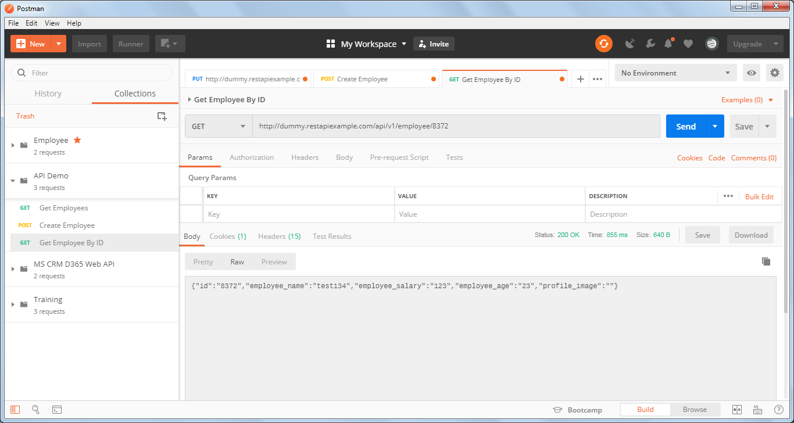

Now, running the PUT request to update employee name and salary

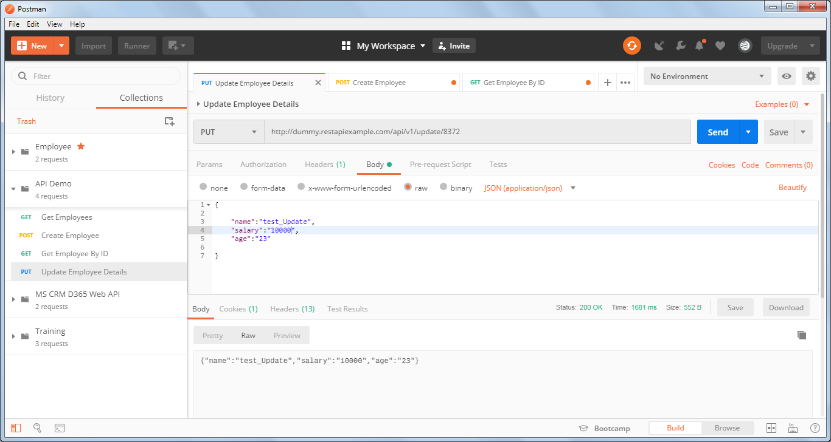

Now again hitting the GET employee by ID request to validate the employee details after the PUT Request:

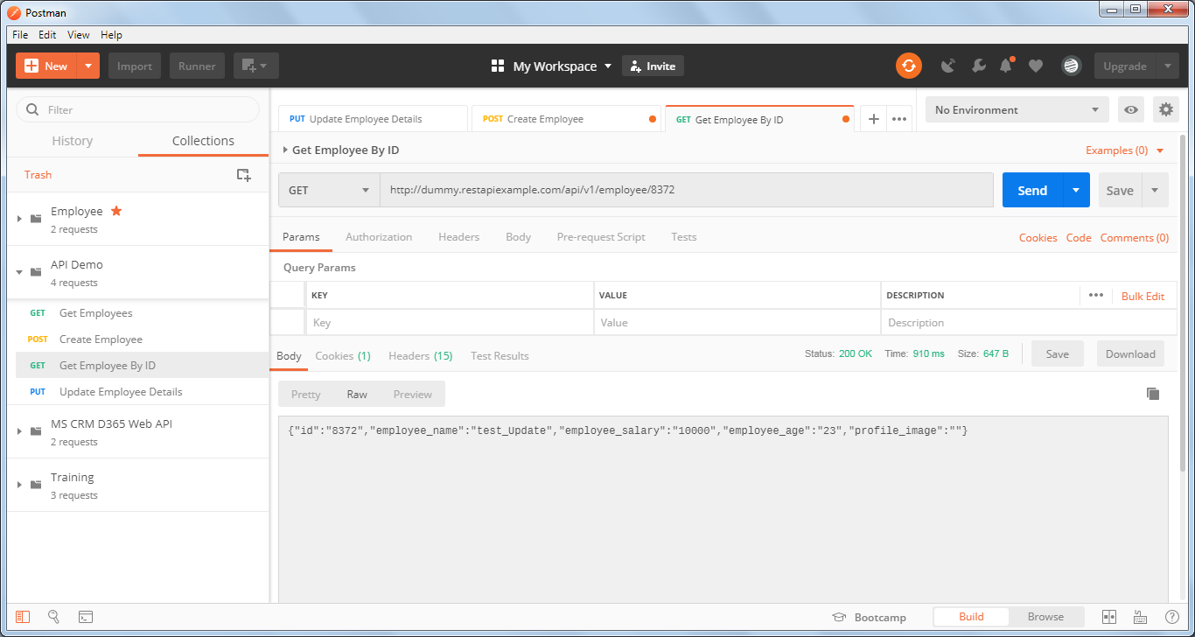

* Sample DELETE Request:

Type : JSON

Description: Delete an employee record

Now trying the employee id: 8372 to delete the record

Correct URL : <http://dummy.restapiexample.com/api/v1/delete/8372>

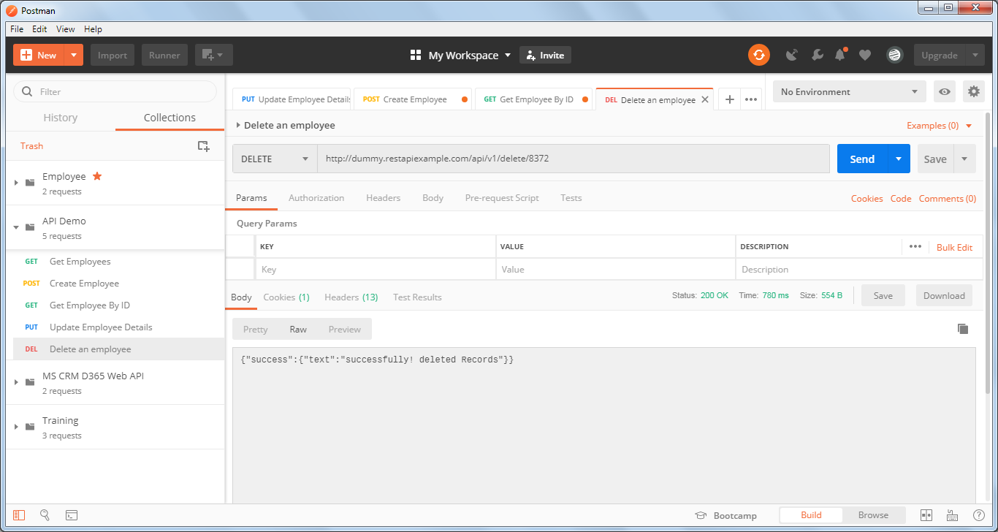

Now again trying to GET the details of deleted Employee id : 8372

